

Excel Assignment - 6

1. What are the various elements of the Excel interface? Describe how they're used.

Ans=>

1. **Ribbon**.:

Home.: Contains common formatting tools

Insert.: used to insert various elements like charts, tables, etc.

Page Layout.: Deals with themes, page setup, and print options.

Formulas.: Contains functions and formula related tools.

Review.: contains functions and formula related tools.

View.: allows users to change the tool.

1. **Worksheet.:** The main space where you enter and manipulate the data.
2. **Formula Bar.**: Displays the content of the active cell and allows you to edit its content.
3. **Quick Access Toolbar.**: allows quick access to commonly used commands.
4. **Status Bar.**: Provides information about current status of the worksheet.
5. **Tabs.**: Each ribbon is organized into tabs.
6. **Columns and Rows.**: there are columns which are vertically arranged and rows which are horizontally arranged.
7. **Etc.**
8. Write down the various applications of Excel in the industry.

Ans=>

1. **Data Analysis.:** it is widely used for the analyzing Business data, trends and performance metrics.
2. **Finance and Accounting.:** it is used for creating and managing budgets, forecasts, etc. and helps in analyzing financial data.
3. **Data Management.:** Organizing and managing employee data such as attendance, payroll and performance.
4. **Healthcare.:** For managing patient data analyzing and doing research on that data.
5. **Marketing and Sales.:** for tracking the sales data, analyzing sales data, creating sales report.
6. On the ribbon, make a new tab. Add some different groups, insert commands in the groups and name them according to their commands added. Copy and paste the screenshot of the steps you followed.

Ans=>

a)Open Excel and Click on the “File” tab then click “Options”

Aaa)sdfmdz Op

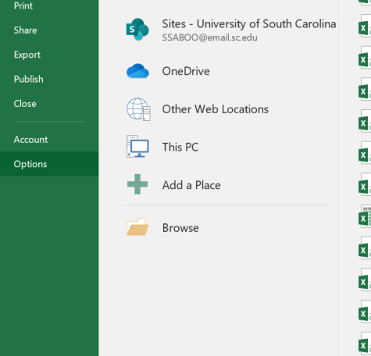

b)Then choose “Customize Ribbons”.

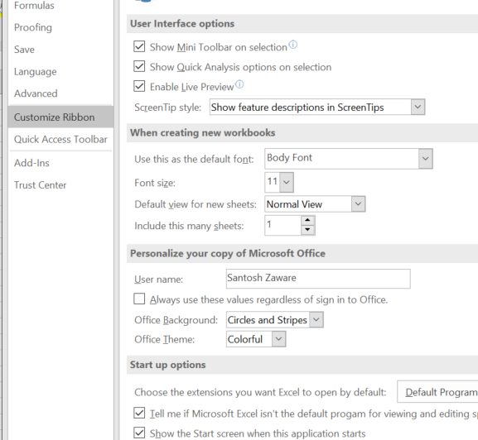

c)You will see all the tabs i.e “Home”, “Insert”, “Page Layout”, etc.

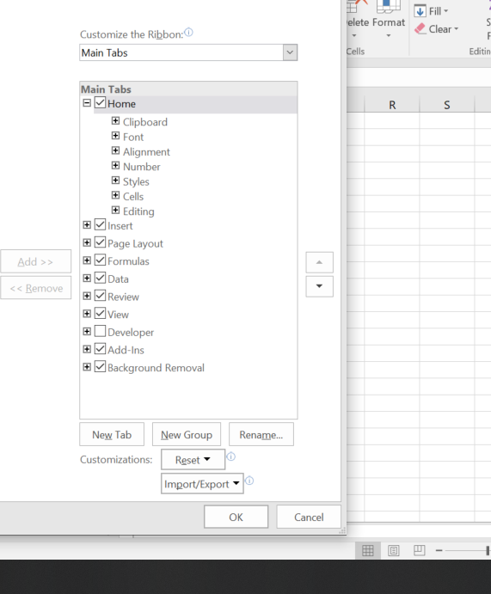

d)Click on the “New Tab ” and then “Rename” respectively

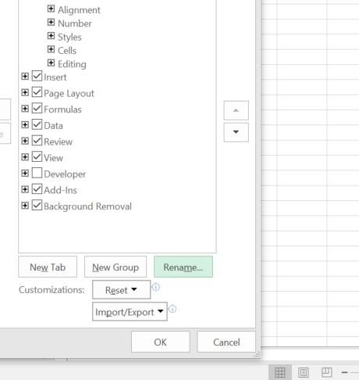

e) Then Choose command categroy from “Choose commands from”.

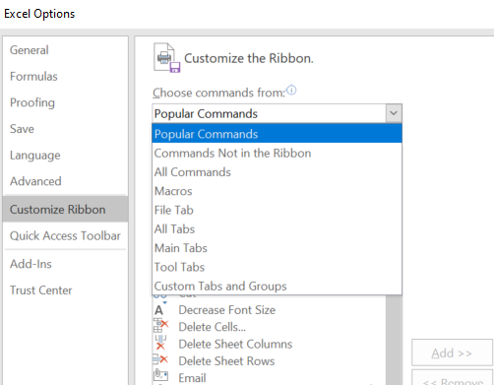

f)Click “Add>>” after selecting the command you want.

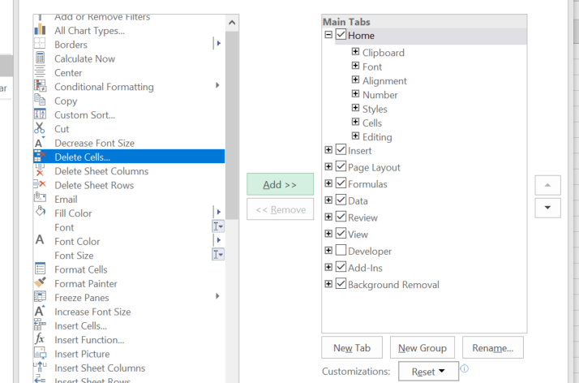

1. Make a list of different shortcut keys that are only connected to formatting with their functions.

Ans=>

1. **Bold Text.:** “Ctrl + B”.
2. **Itilicize Text.**: “Ctrl + I”.
3. **Underline Text.**: “Ctrl + U”.
4. **Open Format Cell Dialogue box.**: “Ctrl +1”
5. **Paste Special.**: “Alt +E, S, V”
6. **Remove Outline Border.**: “Ctrl + shift + _”
7. **Hide Selected Columns.**: “Ctrl + 0”
8. **Hide Selected Rows.**: “Ctrl + 9”
9. **Unhide Columns.**: “Ctrl + shift + ):”
10. **Unhide Rows.**: “Ctrl + shift + (:”
11. **Apply Bottom Borders.**: “Alt + H +B”
12. **Remove Cell Borders.**: “Alt + H, R”
13. What distinguishes Excel from other analytical tools?

Ans=>

1. **Accessibility**.: this tool is widely used for business and educational environments.
2. **Versatility**.: It provides wide range of functions.
3. **Data Visualization**.: It gives you charting and graphing tools, making data understanding easy to interpret.
4. **Formulas and Functions**.: It provides various formulas and functions which makes it easy to apply on various data sets.
5. **User Friendly**.: it’s a very easy to use tool having very simple and easy to use user interface.
6. Create a table and add a custom header and footer to your table.

Ans=>

1. **Create a Table.:** Select your table you want to add Header and Footer, go to the “Insert” tab then click on the “Table”.
2. **Add Custom Header.:** go to “Table Design” tab in the ribbon, choose “properties” group, then choose options “Table Name” choose name for your table.
3. **Add Custom Footer.:** click on the “view” tab, In the “workbook views” then click on “Page Layout”.
4. **Add footer.**: select the “Footer” section, click on the left, center, or right section of the footer. Then enter your custom text or insert elements.
5. **Exit Page Layout View.**: After adding the footer go back to normal view.